A/B Testing Metrics and Analysis Using SQL

Author: Rohinth Shanmugasundaram
Date: 08/12/2023

Project Link: View Report

Objective: As part of the SQL course "Wrangling, Analysis, and AB Testing with SQL," I undertook an assignment to formulate A/B testing metrics and analyse them using a GitHub AB testing emulator. The primary goal was to identify how different item page layouts impact user engagement, conversion rates, and other relevant metrics. This analysis aimed to guide us in optimizing our presentation strategy for enhanced user actions, focusing on a test conducted by the company known as "item_test_2." Specifically, the assignment involved identifying customer behaviour by formulating the following metrics:

- Order Binary for the 30-day Window after Test Start Date: This metric calculates binary results for orders before and after the test assignment. It focuses on the 30-day period following the test_start_date for the test named "item_test_2." The percentage of orders received concerning the total number of items present was computed. Notably, the results revealed a one percent decrease in orders after the assignment.

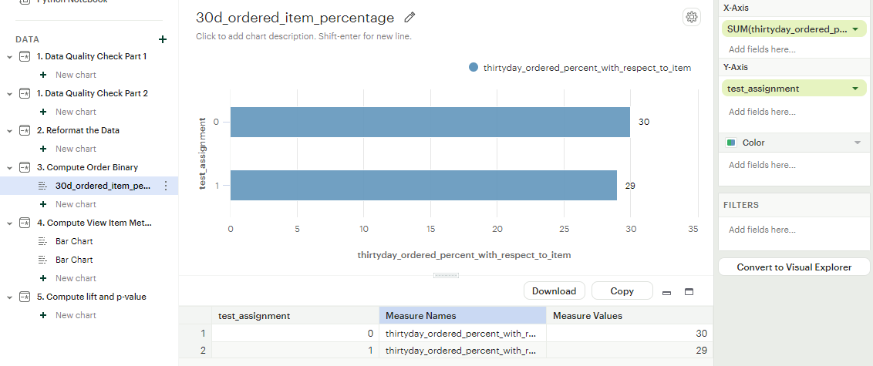

- View Binary for the 30-day Window after Test Start Date: Similarly, these metric computes binary results for views before and after the test assignment. It accounts for items viewed within the 30-day period following the test_start_date for "item_test_2." The analysis includes the percentage of views received relative to the total number of items. Notably, the results indicated a two percent increase in views after the assignment.

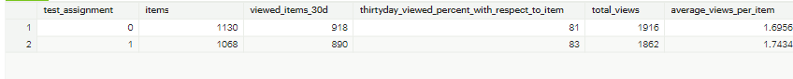

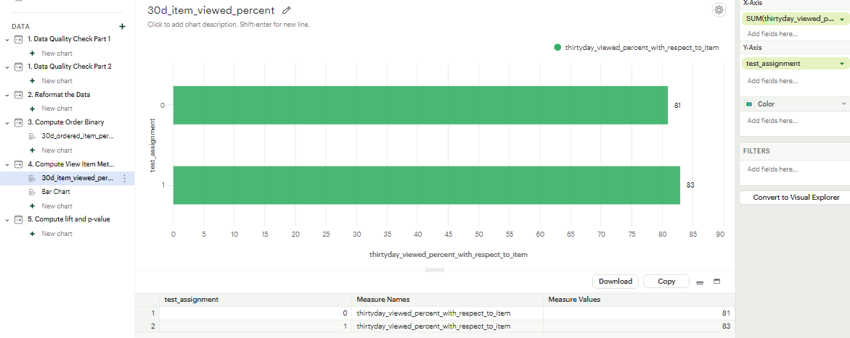

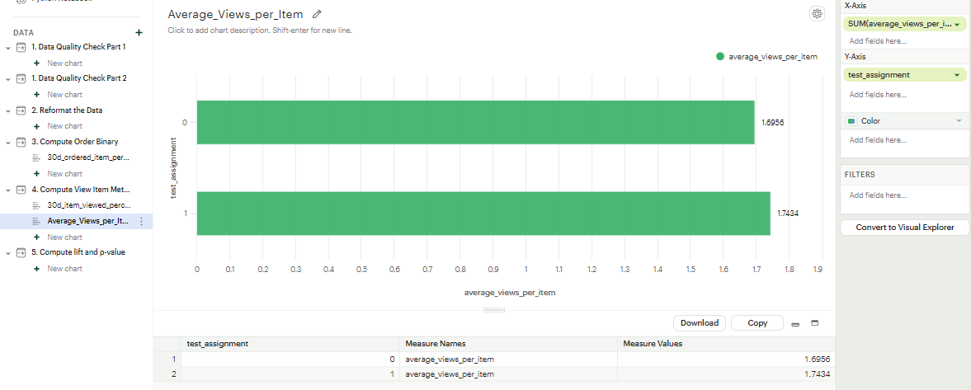

- Computing Lift and P-Value: To assess the significance of the metrics, we computed lift and p-values for the binary metrics, specifically the 30-day order binary and 30-day view binary. The calculations were conducted using a 95% confidence interval.

AB Testing Orders.
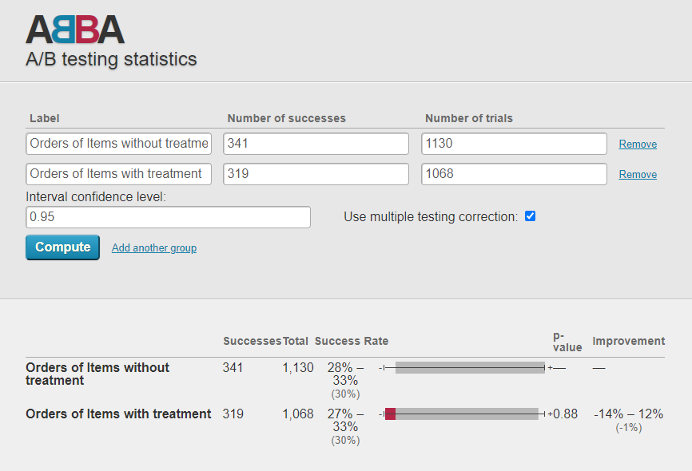

AB Testing Views
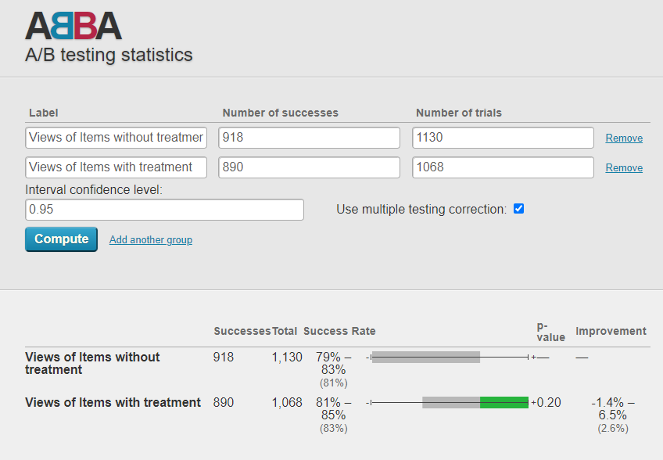

Insights: The analysis provided several key insights:
- Orders decreased by 1% after the assignment, suggesting a potential negative impact.
- Views increased by 2.6%, which initially appeared positive. However, the low p-value of 0.2 indicates insignificance.

Conclusion: In conclusion, the A/B testing analysis of "item_test_2" indicated mixed results. While views increased, the decrease in orders and the low p-value suggest that the test may not have a significant positive impact on item performance. Further analysis and experimentation may be needed to refine the strategies and achieve the desired improvements in user engagement and conversion rates.

Dataset Information:
- Dataset provided by course instructor Katrina Glaeser Poole.
- License: CC0 (Public Domain)

